COURSE CODE/TITLE: | CPE 007/ Programming Logic and Design |  | SECTION: | CPE11S4
DATE PERFORMED: | .05/09/2026 |  | DATE SUBMITTED: | 05/09/2026
NAME: | John Mark J. Barbacena |  | INSTRUCTOR: | Sir Robin Valenzuela

ACTIVITY NO. 4.2 | [Working With Characters and String]
1. PROCEDURE OUTPUT
What procedures did you perform?
#include <iostream>
#include <cctype>

using namespace std;
int main() {
char message[51];
char uppercaseMessage[51];
char lowercaseMessage[51];
int length = 0;
int uppercaseCount = 0;
int lowercaseCount = 0;
int digitCount = 0;
int spaceCount = 0;
int specialCount = 0;
int wordCount = 0;
cout << "Enter a message (max 50 characters): ";
cin.getline(message, 51);
for (int i = 0; message[i] != '\0'; i++) {
length++;
}
for (int i = 0; message[i] != '\0'; i++) {
if (isupper(message[i])) {
uppercaseCount++;
}
else if (islower(message[i])) {
lowercaseCount++;
}
else if (isdigit(message[i])) {
digitCount++;
}
else if (isspace(message[i])) {
spaceCount++;
}
else {
specialCount++;
}
uppercaseMessage[i] = toupper(message[i]);
lowercaseMessage[i] = tolower(message[i]);
}
uppercaseMessage[length] = '\0';
lowercaseMessage[length] = '\0';
for (int i = 0; message[i] != '\0'; i++) {
if (message[i] != ' ' &&
(i == 0 || message[i - 1] == ' ')) {
wordCount++;
}
}
cout << "\n--- Message Report ---\n";
cout << "Length (manual count) : " << length << endl;
cout << "Uppercase letters : " << uppercaseCount << endl;
cout << "Lowercase letters : " << lowercaseCount << endl;
cout << "Digits : " << digitCount << endl;
cout << "Spaces : " << spaceCount << endl;
cout << "Special characters : " << specialCount << endl;
cout << "Word count : " << wordCount << endl;
cout << "UPPERED : " << uppercaseMessage << endl;
cout << "lowercased : " << lowercaseMessage << endl;
return 0;
}
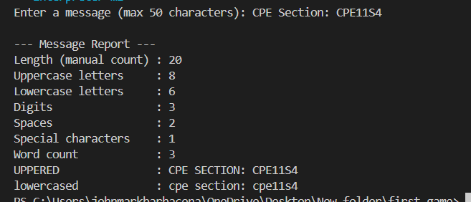
2. ANSWERS TO SUPPLEMENTAL ACTIVITY
Copy and paste the questions from the lab and include your answers after.

3. ARTIFICIAL INTELLIGENCE (AI) USE DISCLOSURE STATEMENT
I hereby declare that artificial intelligence (AI) tools were used, if applicable, in the preparation of this academic work. The following indicates the nature and extent of AI assistance:

Tools Used:
Examples: ChatGPT, Microsoft Copilot, Grammarly, QuillBot, etc.

Purpose of Use:
Examples: grammar correction, idea generation, formatting, summarization, code assistance, explanation of concepts, etc.

Extent of Use:
Explain how AI was used and confirm that it did not replace original thinking, analysis, authorship, or completion of the required work.

By submitting this activity, I affirm that my use of AI complies with T.I.P.’s AI usage policy and does not exceed the permitted limits for similarity, automated content generation, or academic assistance.

I understand that any false, incomplete, or misleading disclosure may be subject to investigation in accordance with due process and may result in sanctions for violation of existing T.I.P. policies.

Lab activities, templates, and related instructional materials shall not be reuploaded, reproduced, distributed, or shared with external organizations or third parties without the prior express written permission of the Technological Institute of the Philippines.

